WEEK ENDING………30/09/2022……………………………………
SUBJECT…HOME ECONOMICS
REFERENCE…SYLLABUS(CRDD,2007), HOME ECONS FOR JHS
FORM……………..BASIC 8……………WEEK………3.……………..
DAY/DURATION | TOPIC/SUB-TOPIC/ASPECT | OBJECTIVES/R.P. K | TEACHER-LEARNER ACTIVITIES | T/L MATERIALS | CORE POINTS | EVALUATION AND REMARKS
TUESDAY  27-09-2022  1:20PM – 2:40PM  80min | Topic;  Free-Hand cutting  Sub-Topic;  apply skills in free-hand  cutting to make a  blouse. | By the end of the lesson the Pupil will be able to;  Cut a blouse before sewing.  RPK  Pupils have seen a blouse before. | Introduction;  Show Pupils pictures of blouse for observations.  Activities;  - Assist Pupils to cut fabrics for designing a blouse using freehand cutting techniques.  - Discuss the steps involved in sewing a blouse.  - Pupils individually practice sewing a blouse.  Closure;  Pupils practice sewing blouse for themselves after making freehand cutting. | Pair of scissors, piece of cloth, sewing machine, hand needle. | 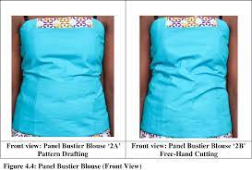  - How to take body measurements  - How to mark directly on your fabric using the measurements you took  - How to cut your fabric without a pattern (using freehand techniques)  - How to make a pencil skirt (detailed cutting and step-by-step sewing instructions)  - How to make peplum top (detailed cutting and step-by-step sewing instructions)  Required  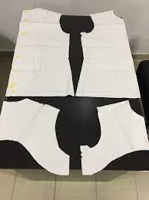 | Exercise;  Outline the steps involved in sewing a blouse.
THURSDAY  29-09-2022  8:05AM – 9:15AM  70min | Topic;  Free-Hand cutting  Sub-Topic;  apply skills in free-hand  cutting to make a  shirt | Objective;  By the end of the lesson the Pupil will be able to;  Cut and sew a shirt using freehand techniques.  RPK  Pupils have been taught how to sew a blouse. | Introduction;  Through questions and answers, introduce the lesson.  Activities;  - Guide pupils to Pre-image a shirt for  themselves.  - Assist Pupils to sketch the shirt .  - Discuss the quantity of fabric required for their  specific styles (designs).  - Using free-hand cutting, pupils to cut out and  sew their shirt/blouse using their own body  measurement.  Closure;  Teacher to supervise and give corrective advice  at each stage of the sewing process. |  | 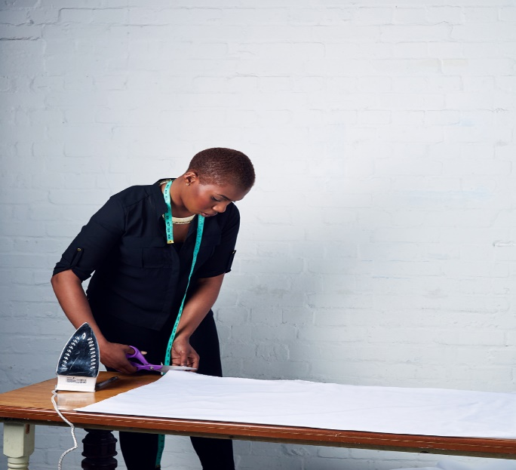  Sewing a t-shirt is quick and easy (once you have a pattern that you know you love), and is a great project for when you need something quick to sew that will still yield fabulous results. | Exercise;  - Write the steps to follow to sew a shirt with freehand cutting.  - Explain the steps to sew a shirt using pattern drafting.  REMARKS

