BASIC 7
WEEKLY LESSON PLAN – WEEK 3
Learning Indicator(s) |  | B7.1.3.1  B7.2.2.2  B7.5.1.1  B7.4.2. 2
Performance Indicator |  | B7.1.3.1.1. Produce pure vowel sounds in context (short vowels)  B7.2.2.2.1.: Determine and analyze central and supporting ideas of texts  B7.5.1.1.4. Identify and explain the effect of different literary features within a text  B7.4.2. 2.4 Write articles on given issues for publication in class and club magazines.
Week Ending |  | 30-09-2022
FORM |  | B.S.7
Subject |  | English Language
Reference |  | Teachers Resource Pack, Learners Resource Pack, Textbook.
Teaching / Learning Resources |  | Textbook, Word Chart, Sentence Card, Paper, Pictures.
DAYS |  | PHASE 1 : STARTER |  | PHASE 2: MAIN |  | PHASE 3: REFECTION
MONDAY  26-09-2022 |  | Strand:  Oral Language  Sub-Strand:  Sounds (vowels, consonants and intonation)  Through questions and answers, introduce the lesson |  | - Assist Learners to pronounce vowel and consonant sounds in contexts.  - Discuss 3 types of intonations with the Learners.  - Learners brainstorm to identify which sounds has high or low intonations.  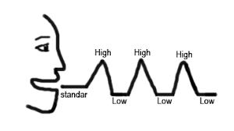  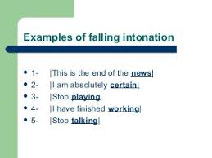 |  | Core Competencies;  - Communication and Collaboration  - Critical Thinking and Problem Solving  - Personal Development and Leadership
TUESDAY  27-09-2022 |  | Strand:  Reading  Sub-Strand:  Summarizing  Learners individually are to guided to read Passages aloud . |  | - Learners brainstorm to explain importance of summarizing main ideas in contexts.  - Assist Learners to summarize main ideas in texts using their own words.  - Assist Learners to find words that explains phrases, sentences and paragraphs in a context.  Importance of Summarizing main ideas in contexts;  - Summarizing teaches students how to discern the most important ideas in a text  - how to ignore irrelevant information  - how to integrate the central ideas in a meaningful way  - Teaching students to summarize improves their memory for what is read  - Summarization strategies can be used in almost every content area.  How do you summarize a paragraph in your own words?  - To summarize, you must read a passage closely, finding the main ideas and supporting ideas.  - Then you must briefly write down those ideas in a few sentences or a paragraph.  It is important to understand the difference between a summary and a paraphrase. A paraphrase is simply a rewriting of a passage in your own words. |  | Core Competencies;  - Communication and collaboration  - Personal development and leadership
THURSDAY  29-09-2022 | Strand:  Literature  Sub-Strand:  Prose, Drama, Poetry  Discuss the meaning of Figures of speech and rhetorical devices |  | - Learners in small group to discuss about examples of figures of speech and their meanings.  - Assist Learners to identify and describe figures of speech and rhetorical devices as they appear in Prose.  A figure of speech that relies primarily on the sound of a word or phrase (or the repetition of sounds) to convey a particular effect is known as a figure of sound. Although figures of sound are often found in poetry, they can also be used effectively in prose.  Figures of Speech Examples  Personification The opportunity knocked at his door  Metaphor It is raining cats and dogs  Simile He is as brave as a lion  Alliteration She sells seashells on the seashore  Onomatopoeia The buzzing bee flew over my head  Hyperbole She has got a pea-sized brain  Euphemism He passed away in his sleep  Irony Your hands are as clean as mud  Anaphora Dr Martin Luther King Jr: “I Have a Dream” Speech  Apostrophe Twinkle, twinkle, little star, How I wonder what you are  Pun Everyone thinks my runny nose is funny, but it’s snot.  Paradox “Some of my biggest triumphs have also been failures,”  Oxymoron You are clearly confused by the situation you have found yourself in  Assonance How now, brown cow?  Metonymy “The pen is mightier than the sword” |  | Core Competencies;  - Critical Thinking and Problem Solving  - Personal Development and Leadership  - Cultural Identity and Global Citizenship  - Creativity and Innovation  - Digital Literacy
FRIDAY  30-09-2022 |  | Strand:  Writing  Sub-Strand:  Text (Types and Purposes)  Learners brainstorm to explain Article writing. | - Discuss the structure of writing an article for publication in a Magazine.  - Assist Learners to identify the topic, purpose, and audience for article writing.  - Learners in small groups to generate ideas about more challenging topics and identify those most appropriate for the purpose.  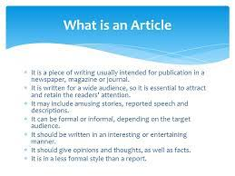  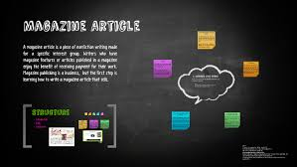  How to Publish an Article in a Magazine in 5 Steps;  - Choose a topic you're passionate about. Before you can see your by line in a magazine publication or website, you'll need to come up with a great article idea.  - Research and write.  - Edit your article.  - Determine which publications to submit to.  - Submit your article. |  | Core Competencies;  - Creativity and Innovation  - Communication and Collaboration  - Personal Development and Leadership  - Critical Thinking and Problem Solving  - Cultural Identity and Global Citizenship  - Digital literacy

